*Records*

Syntax:

val record = { *key* = *value*, … };

* We don’t need to declare the type of the *record*
  + Type checker will be the one to identify the type of the whole record

Sample:

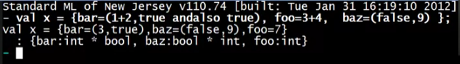

* Alphabetized the fields/keys
* { key: type of the value, … }

More examples:



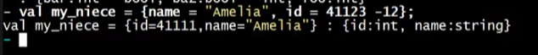

How to access the values?

#*key* *record*

* This will return the *value* of the *key*

Sample:



